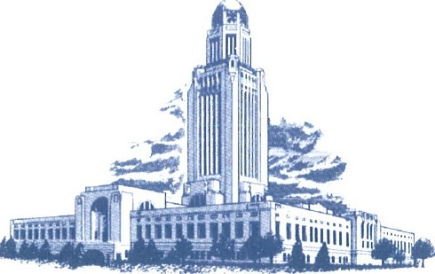
1

STATE of NEBRASKA
OFFICE OF THE GOVERNOR

LINCOLN

EXECUTIVE ORDER NO. 25-16
Protecting the Life, Health, and Welfare of Pregnant Women and Unborn Human Life
WHEREAS, the State of Nebraska has a strong culture and longstanding tradition of protecting and defending the life and liberty of unborn children; and

WHEREAS, the State of Nebraska has long maintained a compelling interest in promoting a culture of life and ensuring that public taxpayer dollars do not directly or indirectly support abortion or abortion-affiliated providers; and

WHEREAS, the State recognizes that the availability of women's health and family planning services is important in providing for healthy families and children; and

WHEREAS, the Nebraska Department of Health and Human Services ("DHHS") expends taxpayer dollars to pay for health care services, including family planning services; and

WHEREAS, the Nebraska Legislature has declared by statute that "[a] majority of the citizens of the State of Nebraska, like other Americans, oppose the use of public funds, both federal and state, to pay for abortion," Neb. Rev. Stat.§ 44-8402(£), and has passed laws preventing the use of public funds to subsidize abortion, Neb. Rev. Stat.§§ 44-8403, 71-7606(3); and

WHEREAS, in the wake of Roe v. Wade, 410 U.S. 113 (1973), the State of Nebraska's legislative response to Roe v. Wade was preserved in Neb. Rev. Stat. § 28-325. Section 28-325 makes clear that the people of Nebraska disagreed with the government intrusion that Roe represented which prevented the State "from providing adequate legal remedies to protect the life, health, and welfare of pregnant women and unborn human life." Section 28-325 was "an expression of the will of the people of the State of Nebraska and the members of the Legislature to provide protection for the life of the unborn child whenever possible"; and

WHEREAS, in Dobbs v. Jackson Womens Health Organization, 597 U.S. 215 (2022), the United States Supreme Court stated that "[t]he Constitution does not confer a right to abortion; Roe v. Wade, 410 U.S. 113, and Planned Parenthood of Southeastern Pa. v. Casey, 505 U.S. 833 [1992], are overruled."; and

WHEREAS, the Dobbs decision restored the State of Nebraska's ability to provide adequate legal remedies to protect the life, health, and welfare of pregnant women and unborn human life that had been restricted by the Roe and Casey decisions; and

WHEREAS, Congress has prohibited the use of federal funds to pay disqualified entities who perform elective abortions, One Big Beautiful Bill Act, Pub. L. 119-21, § 71113, 139 Stat. 72, 300 (2025); and

WHEREAS, the payment of taxpayer funds to abortion clinics, for any purpose, results in the subsidy of abortion; and

WHEREAS, DHHS has the authority and obligation to determine the qualifications of providers seeking participation in the Medicaid program, and may exclude those who do not meet applicable standards; and

WHEREAS, DHHS has the discretion to sanction providers if they have been suspended, excluded, or terminated from participation in another governmental program, been convicted for violations of Medicaid, or any other state's Medicaid program, or have had sanctions applied by the DHHS's agents or assignees or any other state's Medicaid program. 471 NAC 2, 005.01(19); and
WHEREAS, DHHS must deny or terminate the enrollment of a provider that has been excluded or terminated from participating in Medicare or Medicaid or Child Health Insurance Program in any state. 471 NAC 2, 005.0l(C); and
WHEREAS, DHHS may sanction all known affiliates of a provider or other persons associated with an enrolled provider. DHHS may determine the violation, failure, or inadequacy of performance, which resulted in a provider sanction, took place in the course of the affiliate or otherwise associated person's official duty or with the knowledge or approval of the affiliate or associated person. 471 NAC 2, 005.04; and

WHEREAS, DHHS may sanction a provider for providing services that fail to meet the relevant standards for medical care and administration. 471 NAC 2, 005.01 (e.g., improper billing and claims payment, altering medical records, submitting false information, improper records, failing to provide quality, necessary and appropriate services, etc.); and

WHEREAS, on June 26, 2025, the United States Supreme Court in Medina v. Planned Parenthood South Atlantic, 606 U.S. ___ (2025), reaffirmed the principle that states retain primary authority to determine the qualifications of Medicaid providers; and

WHEREAS, on December 20, 2016, the Texas Health and Human Services Commission's Office of Inspector General terminated the enrollment of many abortion providers, including Planned Parenthood affiliates, from the Texas Medicaid program; and

WHEREAS, Oklahoma Governor J. Kevin Stitt ordered Oklahoma state agencies to immediately cease providing State or local funds to any individual or entity directly affiliated with a physician, medical practice, or other organization providing abortion services or facilitating the procurement of abortion services. Governor Stitt Executive Order 2025-16 (July 31, 2025); and

WHEREAS, On July 13, 2018, South Carolina Governor Henry McMaster issued Executive Order 2018-21 directing the termination of the enrollment of abortion clinics from South Carolina's Medicaid program. After South Carolina's victory in the Medina case and subsequent legal process, on October 22, 2025, the Medina case was dismissed and South Carolina Department of Health and Human Services' previous disenrollment of all abortion providers became final; and

WHEREAS, although the State should not contract with abortion clinics for family planning services, the State also should not deny Nebraskans access to necessary medical care and important women's health and family planning services, which are provided by a variety of other non­ governmental entities and governmental agencies; and

WHEREAS, there are at least eight legal bases for this Executive Order:

- Neb. Rev. Stat. § 28-325; and
- Neb. Rev. Stat. § 44-8402, § 44-8403, § 71-7606(3); and
- 471 NAC 2, 005.01(1) - (39); and
- 471 NAC 2, 005.01(13); and
- 471 NAC 2, 005.01(19); and
- 471 NAC 2, 005.0l(C); and
- 471 NAC 2, 005.04; and
- One Big Beautiful Bill Act, Pub. L. No. 119-21, 139 Stat. 72 (2025).

NOW THEREFORE, I, Jim Pillen, Governor of the State of Nebraska, under and pursuant to the authority vested in the Governor by the Constitution and the laws of the State of Nebraska do hereby order and direct that, to the fullest extent permitted by law:
- DHHS shall provide adequate legal remedies to protect the life, health, and welfare of pregnant women and unborn human life in accordance with Neb. Rev. Stat.§ 28-325.

- DHHS shall terminate the enrollment of providers that have been excluded or terminated from participating in Medicare or Medicaid or Child Health Insurance Program in any state.
- DHHS shall consider sanctions, including disenrollment of any provider, affiliate of a provider, or other person associated with an enrolled provider sanctioned in another state.
- DHHS shall consider sanctions, including disenrollment of a provider no longer eligible to enroll in Medicaid in another state.
- DHHS shall review providers which are no longer eligible to enroll in Medicaid in another state and providers that have been disenrolled in another state and determine whether these providers have met the relevant standards for medical care and administration in the State of Nebraska in accordance with 471 NAC 2,005.01. DHHS shall consider sanctions, including disenrollment of providers who have not met the relevant standards.
- DHHS shall consider sanctions for all known affiliates of a provider or other persons associated with a sanctioned enrolled provider.
- DHHS shall place terminated or excluded person or entities on the Medicaid Excluded Provider list.
- If any provision of this Order, or the application of any provision to any person or circumstance, is held to be invalid, the remainder of this Order and the application of its other provisions to any other persons or circumstances shall not be affected thereby.
Executive state agencies shall cooperate in the implementation of this Order to the fullest extent possible under Nebraska law.

Agencies will be fully compliant with this Executive Order as soon as practicable, but in no event later than November 281\ 2025.

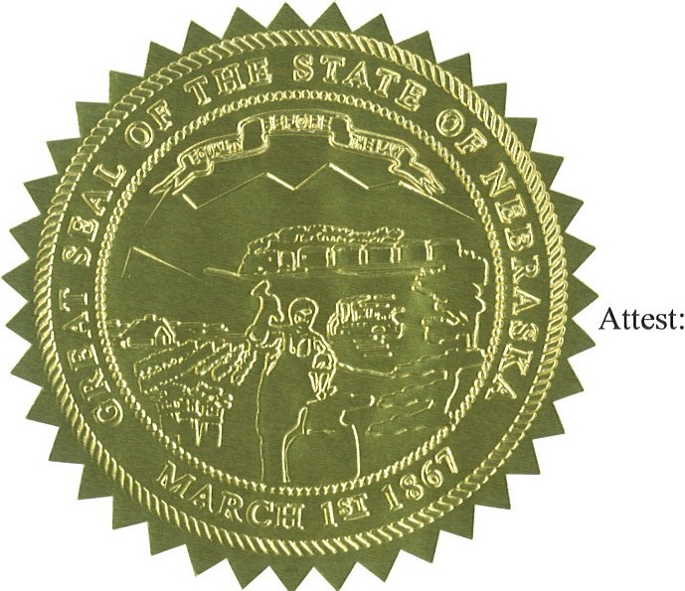
IN WITNESS THEREOF, I hereunto set my hand and cause the Seal of the State of Nebraska to be affixed this 6th day of November 2025.
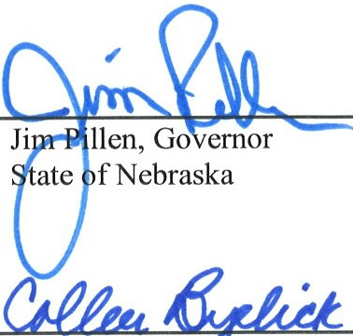
Colleen Byelic Acting Secretary of State, State of Nebraska

